TriNation meeting
Aberdeen, October 12th-13th 2016
 | October 12th
9.30 | Registration opens, Coffee & Refreshments
10.45-12.00 | Welcome &  Situation updates | Chair: Rob Raynard
10.45 | Welcome | Rob Raynard, Marine Scotland Science
11.00 | Update on the situation in Scotland | Marian McLoughlin, Fish Vet Group
11.15 | Update on the situation in Ireland | Susie Mitchell, Vet-Aqua International
11.30 | Update on the situation in Norway | Brit Hjeltnes, NVI
11.45 | Industry update for Norway | Marit Stormoen, Marine Harvest
12.00 | Lunch
13.00-17.30 | PD management and vaccination | Chair: Alexander Murray
13:00 | The management of PD in Scotland | Abby Irish, Scottish Salmon Company
13.20 | The management of PD-free zones in Norway | Tore Hovland, Patogen
13.45 | The economics of PD management | Arnfinn Aunsmo, AquaGen
14.15 | DNA vaccination against SPDV suppression of viremia, protection and individual monitoring | Catherine Collins, Marine Scotland Science
14.40 | Coffee
15.10 | Use of histopathological findings for vaccine efficacy testing in a salmon alphavirus challenge model | Jeffrey Wolf, EPL, Inc.
15.35 | PD DNA vaccine safety and efficacy | Lisa Phillips, ELANCO
16.00 | Vaccine developments | Ingunn Sommerset, MSD Animal Health
16.25 | Next-Generation salmonid alphavirus vaccine development options | Mia Hikke, MSD Animal Health
16.50-17.30 | Discussion of research needs for industry - immunology and vaccine developments, strategies for vaccine use, policy and regulatory requirements/obstacles
19.30  for  20.00 | Conference dinner at Copthorne Hotel, Aberdeen

Gold Sponsors for the 2016 TriNation meeting:
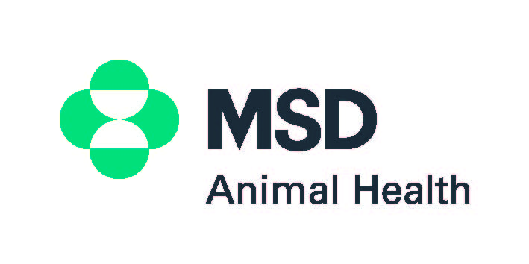

 | October 13th
8.30-  9.30 | Coffee
9.30-12.35 | New research I | Chair: Mona Dverdal Jansen
9.30 | First detection of Piscine reovirus in France | Laurent Bigarre, Anses
9.55 | Effects of health diet on heart and skeletal muscle pathology and blood chemistry parameters | Julia Mullins, Skretting
10.20 | Experimental piscine orthoreovirus infection mediates protection against PD | Magnus Vikan Røsæg, Salmar
10.45-  11.15 | Coffee and refreshments
11.15 | SAV3 infection and shedding rate is dose dependent | Sonal Patel, Institute of Marine Research
11.45 | PD effects on digestibility | Magnus Vikan Røsæg, Salmar
12.10 | Salmonid alphavirus 3 (SAV3) recombines in Atlantic salmon | Elin Petterson, NMBU
12.35-13.35 | Lunch
 | New research II | Chair: Catherine Collins
13.35 | Rainbow trout, a risk for PD in Atlantic salmon? | Rodrigo Belmonte, MSD Animal Health
14.00 | The occurrence of virus infections in wild salmonids and escaped farmed salmon | Abdullah Madhun. Institute of Marine Research
14.25 | In-field PD experiences: results from on-farm interviews | Mona Dverdal Jansen, NVI
14.50 | Epidemiological study of CMS | Julie Svendsen, NVI
15.15- | Coffee and departure

Bronze Sponsor for the 2016 TriNation meeting:

